**Thematic Panel 1**

***Ideologies & Conspiracy Narratives*  
*Working Group of EU Knowledge Hub on Prevention of Radicalisation***

**Meeting 2**

**The Nexus Between**

**Organised Crime and Extremism:**

***How Ideologies and Conspiracy Theories Fuel the Symbiotic Relationship Between Organised Crime and Extremism***

12-13 June, Aalborg, Denmark

**CONCLUSIONS PAPER**

Authors: Stéphanie O'Keeffe, Isabel Pérez Pérez, Fabian Wichmann, Vasileios Theofilopoulos

**Version: XX**

**Date: xx/xx/xxxx**

**Introduction**

The second meeting of the EU Knowledge Hub Thematic Panel 1 (Ideologies & Conspiracy Narratives), held in Aalborg, Denmark, brought together a multidisciplinary group of researchers, practitioners, and policymakers to investigate the evolving intersections between organised crime (OC) and violent extremism across Europe. This complex relationship, frequently referred to as the "crime-terror nexus," is a growing concern, not only because of its implications for national and EU-wide security, but also its impact on civil society, governance, and social cohesion. Overlap in areas such as drug trafficking, robbery, petty crime, kidnapping or document falsification are common and ideology and criminality can be mutually reinforcing. Ideological motives have become interwoven with criminal activity, with criminal and terrorist groups drawing on overlapping networks to create a hybrid field where radicalisation and criminal activity occur simultaneously. This phenomenon is not confined to one ideological spectrum but rather can be seen across different forms of extremism, from the far-right and the far-left, Islamist, to ethnonationalist movements and beyond, as well as groups without a rigid ideology.

The Thematic Panel meeting sought to unpack how ideology, violence, economic interests, territorial control, and social networks converge to facilitate cooperation between criminal and extremist actors. It explored questions such as how extremists groups benefit from criminal activities; how criminal and ideological networks converge, including examples from far-right movements, outlaw motorcycle gangs (OMCs), and Islamist groups; the role of territorial control and narratives aimed at recruiting young people; why young people are particularly vulnerable to recruitment to spaces that combine power, belonging and ideology; and how prevention practitioners, law enforcement, and civil society can work together, with a focus on strategic communication, digital resilience, and early intervention.

The meeting featured presentations from leading experts, real-life case studies, and group-based discussions designed to extract practical insights and forward-looking policy recommendations. The complexity of the nexus was evident in the wide range of examples from different EU Member States, illustrating both deliberate and opportunistic affiliations depending on local, regional, and geopolitical contexts.

This summary aims to capture some of the key points of discussions held during the meeting and is intended to serve as a reference for shaping more effective and integrated responses to the growing convergence of organised crime and violent extremism across Europe and beyond.

**Key take-aways of the meeting**

**Inter-agency coordination:** To strengthen local resilience, greater coordination is needed between government agencies, particularly between social work and security services, as well as between departments investigating financial fraud, and those working on the topic of extremism. To facilitate identification, investigation and prosecution of organised crime/ideological networks, there is a need for political will to prioritise and resource this issue, through the creation of inter-agency task forces that include law enforcement, education, municipalities, prisons, probation services, tax authorities, customs, and intelligence services.

**Recognition of Hybrid Structures:** Participants acknowledged that many criminal and extremist groups have evolved into hybrid entities that defy traditional categorisations. These groups may pursue ideological goals through criminal means or exploit ideological narratives for financial gain and organisational growth. Examples included outlaw motorcycle gangs (OMCs) aligning

with right-wing extremist ideologies, and Islamist organisations using businesses and charities to fundraise under the radar.

**The Role of Ideology:** While ideology is in some cases central to group identity, it also serves as a flexible tool for justification and recruitment for others. In some instances, ideology is used opportunistically to legitimise violence or exploit vulnerable populations. While other examples showed that ideologically driven groups, such as racially motivated right-wing extremists might overlook ideological purity for strategic gain.

**The Role of Family:** The family unit, often seen as the cornerstone of society, plays a complex and multifaceted role when it comes to the challenges of extremism and organised crime. Its influence can be a conduit for negative societal forces but also act as a powerful bulwark against extremism, particularly when well supported.

**Cross-Border and Transnational Dimensions:** Participants observed clear transnational connections among extremist and criminal groups, especially in the Western Balkans and Nordic countries. These include cross-border arms trafficking, drug smuggling, and recruitment pipelines linking violent right-wing groups across Austria, Germany, Sweden, and Poland.

**Operational Blind Spots and Structural Gaps:** The prison system was repeatedly cited as a significant blind spot in national prevention frameworks. Prisons function as incubators for radicalisation and often serve as environments where organised crime and extremism intersect. However, national policies and institutional capabilities to address radicalisation in incarceration settings need to be strengthened. There is also a potential risk of corruption among prison staff which should be considered, as it can worsen existing challenges by enabling the spread of extremist ideologies or illicit activities within correctional facilities.

**Technological and Financial Innovations:** The role of technology in shaping the crime-terror nexus was highlighted. Cryptocurrencies, encrypted messaging apps, and digital crowdfunding platforms were identified as key tools used by hybrid groups to evade detection and facilitate operations. New and emerging digital platforms are providing these groups with reach and operational security previously unavailable.

**Strengthening Intelligence:** There is an urgent need to significantly increase strategic and research and operational analysis of the nexus between organised crime and extremism and requires greater focus from institutions such as Europol, think tanks, and other relevant bodies. This area is currently underrepresented in official reports, such as Europol's annual EU Terrorism Situation and Trend Report (TESAT) and EU Serious and Organised Crime Threat Assessment (SOCTA).,

**Highlights of the Discussion**

**Current Developments at the Nexus of Extremism and Organised Crime**

The meeting began with a **comprehensive overview of current developments in the crime-terror nexus**, stressing that financial incentives are often the primary driver behind these affiliations. Examples included how Islamist groups like ISIS leveraged oil sales, artefact trafficking, and *hawala* networks to generate wealth. The **growing sophistication of criminal operations** was highlighted, including cyber-enabled fraud and infiltration of legitimate enterprises. The need to reconceptualise organised crime not merely as violent gangs but as flexible, innovative, and networked actors capable of adapting quickly to changing opportunities was stressed.

A seven-country study examining how violent right-wing extremist (VRWE) groups maintain operational and ideological ties with organised crime networks was presented and discussed. The findings revealed that VRWE actors frequently collaborate with outlaw motorcycle gangs, hooligan factions, and white supremacist prison gangs through transnational drug and arms trafficking, shared personnel, and mutual support structures. Despite common assumptions that ideological and racial barriers would prevent such alliances, pragmatic motivations often override ideological rigidity. **Gaps were identified**, such as the absence of structural data, siloed law enforcement approaches; a lack of specialised knowledge and of strategic and operational analysis in the nexus between organised crime and extremism; and the absence of statistical categorisation for links between violent right-wing extremism and organised crime further obscures these networks. To counteract this threat, the **establishment of joint VRWE-OC task forces was suggested**, to ensure better integration across law enforcement sectors, and a ‘follow the money’ strategy to disrupt shared financial infrastructures.

**Between Ideology and Profit: Where Extremism Meets Organised Crime**

Breakout groups explored the **mechanisms that enable extremists and criminal actors to collaborate**. A recurring theme was the concept of ‘service exchange’ where one group provides logistics, weapons, or financing to another. Discussions pointed to **prisons as hotbeds for recruitment and enabling environments** for alliances to be formed. Participants expressed concern over the **lack of legal clarity in prosecuting hybrid actors** and the question of whether they should they be treated as terrorists, criminals, or both. Concerns were also raised about the problematic **intersection between certain religious interpretations (or misinterpretations) and organised crime**, which was identified as a significant blind spot and a taboo subject. This extends to the Salafists and radical Islamists exploiting Islamophobia to portray themselves as victims, while simultaneously using cultural and ethical elements to advance their radical ideologies. Participants also highlighted the increasing **involvement of younger children** involved in organised groups, which is a trend often overlooked or inadequately addressed. Additionally, they noted how the media narrative often distorts the reality of criminal groups, particularly concerning those identified as Muslim (e.g., confusing Georgian and Chechen actors). The need for stronger cross-institutional mechanisms and joint investigations was emphasised.

**Prevention in Action: Case Studies**

The meeting brought to light operational efforts in the area of prevention: **Exit Sweden's** targeted interventions with radicalised individuals, **Austria’s AG Corium**, which disrupts outlaw motorcycle gang activities, and the **Greek case of organised crime and extremism in Thessaloniki**. These cases illustrated the potential of exit work, particularly when incorporating a family-based approach, psychological support, and multi-agency coordination. Challenges included navigating youth engagement, the decreasing legitimacy and trust in authorities and government structures, the legal limitations in preventing criminal acts, monitoring messenger services and online behaviour of targets, and the high costs of technical investigations. It was also emphasized that a purely criminal justice approach is insufficient to deconstruct narratives and that socio-economic issues must be addressed. This includes addressing the **appeal of extremist and criminal lifestyles through local community work.**

**Understanding the Nexus: Case Studies**

International case studies offered key insights which were then further explored in breakout groups.

**Denmark:** Islamist leaders in Aarhus mobilised marginalised youth by portraying themselves as defenders of faith and provided a sense of belonging. These efforts were supported by international extremist actors and fundraising for criminal activities were facilitated through legitimate channels like charity and education.

**Brazil:** Structural factors such as poverty, repression, and limited access to education are drivers of youth participation in drug trafficking. Here, criminal activity is less ideologically driven and more about survival and access to the informal economy. There is an increasing trend of women, particularly in their 20s, being recruited into extremist and organised crime groups. This often occurs due to existing connections through fathers, partners, or friends already involved in organised crime and motivated by a desire to gain ‘respect’ and status.

**Italy:** This case demonstrated how ideologies and conspiracy theories fuel a symbiotic relationship between organised crime (Mafia) and extremism (neo-fascist, jihadist). Nationalist youth movements were shown to merge political ideology with street-level crime, targeting leftist groups, refugees, and state institutions. These groups maintain strong online propaganda arms and receive support from broader VRWE networks. Conspiracy theories such as ‘Betraying State’ and ‘Great Replacement’ act as a ‘conspiracy glue’ that justifies violence for all groups.

**Central Asia:** Kyrgyzstan's traditional ‘*thieves' world’* criminal order, governed by figures like Kamchi Kolbayev largely collapsed after he was fatally shot during a law enforcement crackdown in 2023. Combined with ethnic fragmentation, Muslim identity is gaining traction in prisons and streets. Former criminals are strategically adopting visible piety, blurring the lines between genuine reform and repositioning, especially within communal prison systems. The absence of the old vertical criminal hierarchy has led to the formation of new, fluid transnational ties based on diaspora connections and faith-based fraternities, representing a hybridisation of organised crime and extremism.

**Strengthening Evaluation**

Finally, a presentation on the topic of evaluation highlighted that accessible frameworks for improving the assessment of P/CVE programmes are essential, not only considering developments in the fields of organised crime and extremism. Tools such as the 'theory of change' and assessment frameworks were introduced, which aim to ensure that interventions are goal-oriented, evidence-based, and adaptable. Group exercises illustrated how practitioners can define indicators, clarify intended outcomes, and better assess programme effectiveness. Particular emphasis was placed on the shift from a control-oriented to a learning-oriented evaluation culture.

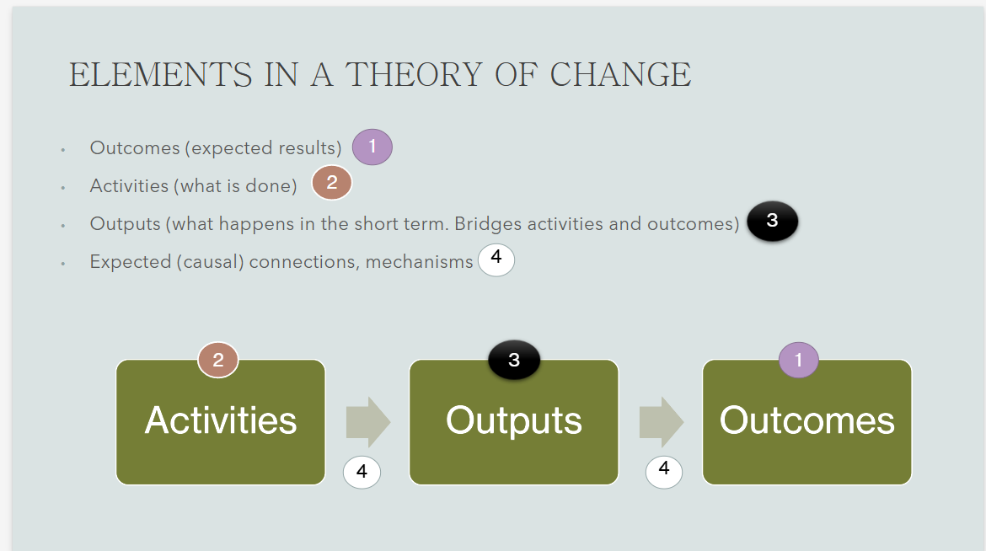

Slide from the presentation of Special advisor on Evaluation at the EU Knowledge Hub on Prevention of Radicalisation, Martin Baeksgaard Jakobsen.

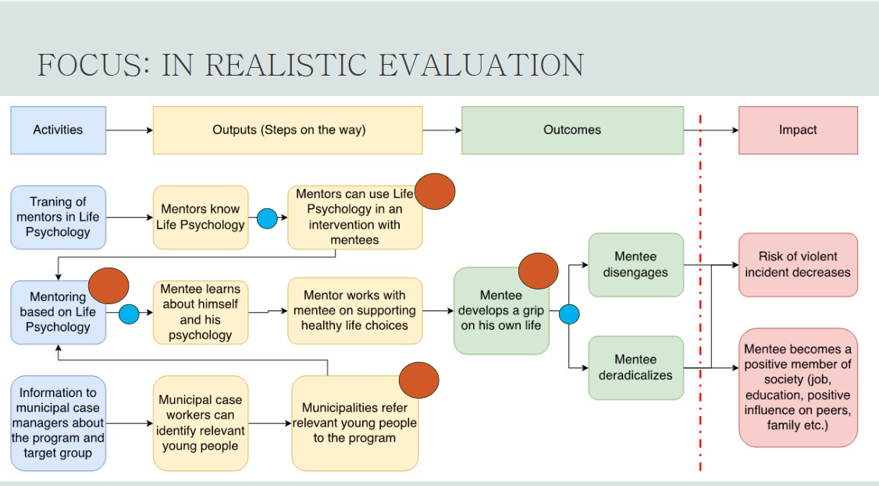

Slide from the presentation of Special advisor on Evaluation at the EU Knowledge Hub on Prevention of Radicalisation, Martin Baeksgaard Jakobsen.

**Conclusions and Recommendations**

The Thematic Panel elaborated the following **conclusions**:

* The relationship between organised crime and extremism is multifaceted and context-sensitive, often driven by opportunism and business rather than ideology alone.
* Traditional dichotomies between terrorist and criminal actors are no longer appropriate to describe the current landscape. Hybrid actors exploit legal loopholes, institutional silos, and socio-economic vulnerabilities.
* Prisons, marginalised communities, and digital platforms are among the key settings where convergence is most pronounced.
* Right-wing extremist actors, while often downplayed, pose a significant and growing threat, especially in terms of transnational connections and ideological infiltration of institutions.
* Despite increased awareness, most EU Member States lack integrated strategies and adequate resourcing to address the nexus holistically.
* A victim-centred approach is crucial in dealing with organized crime and extremism to ensure that the recovery, safety, and rights of those most affected are prioritised throughout justice and support processes.

Slide from Alexander Ritzmann’s presentation

The Thematic Panel elaborated the following **recommendations**:

**For Policymakers**

* Develop comprehensive national strategies and explore new funding avenues to tackle hybrid threats, incorporating both counterterrorism and organised crime perspectives.
* Create legally mandated Joint Task Forces including law enforcement, tax agencies, customs, and intelligence services to target overlapping networks.
* Enhance cross-border data sharing and intelligence coordination through Europol and other EU mechanisms, with a particular emphasis on the nexus between extremism and organised crime.
* Promote inclusive, long-term prevention frameworks that address socio-economic conditions that contribute to radicalisation.

**For Practitioners**

* Expand and fund multi-agency intervention programmes that incorporate exit work, mental health and social services, and education.
* Improve prison-based deradicalisation efforts by investing in staff training and screening of community partners.
* Promote local-level engagement to empower frontline workers, schools, and parents in prevention efforts.
* Carry out a mapping of successful interventions and best practices that can be shared among practitioners.
* Create alternative spaces for young people to access alternative narratives.
* Foster inter-service cooperation at the community level that considers religious trends and mitigates the instrumentalization of religion in radicalisation efforts.

**For Researchers**

* Prioritise ethnographic and longitudinal research to understand the evolution of hybrid groups and radicalisation pathways.
* Study the role of digital subcultures, conspiracy theories, and gamification in drawing young people into extremist-criminal networks.
* Encourage transdisciplinary approaches combining criminology, political science, sociology and psychology.
* The role of gender should be further explored as the role women play in these networks remains unclear and under-researched.

**Cross-cutting Recommendations**

* Develop harmonised categorisation and statistical tools to track hybrid group activities across jurisdictions.
* Foster partnerships between civil society and state actors to detect early signs of convergence between criminal and extremist behaviours.
* Embed theory-based evaluation practices in all P/CVE and OC interventions to ensure continuous learning and improvement.

|  |
| --- |
| **Further Reading**  • Akrap, G. (2023). Transnational linkages between violent right-wing extremism, terrorism and organized crime - case of Croatia. CounterExtremism Project.   * Alvanou, M. (2025). The danger of nationalist extremism in Europe: The “Defend Salonica” case in Greece. <https://www.itstime.it/w/the-danger-of-nationalist-extremism-in-europe-the-defend-salonica-case-in-greece-by-maria-alvanou/>   • Basra, R., & Neumann, P. R. (2017). Crime as Jihad: Developments in the Crime-Terror Nexus in Europe. CTC Sentinel, 10(9), 1-6.  • Boiarov, V.; Larkin, M.; Kyrychenko, O.; Penkov, S.; Kruhlov, O. (2021). Features of the investigation of hooliganism committed by football fans. Vol. 39, No. 69 “Cuestiones Políticas.” Universidad del Zulia Maracaibo, Venezuela.  • Bologna, C. & Vianna de Azevedo, C. (2023). The Nexus between Terrorism and Transnational Organized Crime. United Nations Interregional Crime and Justice Research Institute.  • CT Morse Counter-Terrorism Monitoring, Reporting and Support Mechanism. (n.d.). Examining the Nexus between Organised Crime and Terrorism and its implications for EU Programming.   * European Center for Populims Studies. (2021). CasaPound Italy: The Sui Generis Fascists of the New Millenium. https://www.populismstudies.org/casapound-italy-the-sui-generis-fascists-of-the-new-millennium/   • EU Knowledge Hub (2025). Town Hall Meeting. Preventing and Countering Terrorism and Violent Extremism: Challenges and Joint Responses Towards a new EU Agenda.  • European Commission. (2025). ProtectEU: A European Internal Security Strategy.COM (2025) 148 final.  • EUROPOL (2025). European Union Serious and Organised Crime Threat Assessment, the Changing DNA of Serious and Organised Crime.  https://www.europol.europa.eu/cms/sites/default/files/documents/EU_TE-SAT_2025.pdf   * Wagner, B.; Wichmann, F.; & Krause U. (2024). Extremism and Organised Crime: Orientations for dealing with EXOR complexes in the consulting process (German) <https://www.exit-deutschland.de/file_download/72/Extremismus+und+Organisierte+Kriminalit%C3%A4t.+Handreichung.pdf>   • Kirkeby, A.; Klyhs, V.; de Deus, J.; Regeni, P. - RAN Policy Support (2023). Undesirable Foreign Funding of Extremism in EU Countries.  • Marrero Rocha, I., & Ruipérez Canales, J. (2022). From financing needs to criminal terrorism: The role of terrorist financing in crime-terror relations. Oñati Socio-Legal Series, 12(4), 762-789.  • RAN Ex Post Paper (2018). Learning from adjacent fields: the relation between extremism and hooliganism. Study visit to Warsaw (PL).  • RAN Infographic (n.d.) What is the Connection between Crime and Terrorism?  • Ritzmann, A. (2023). Transnational Linkages between Violent Right-Wing Extremism, Terrorism and Organized Crime. CounterExtremism Project.  • Scaturro, R. and Fruscione, G. (2025). Beyond Ideology: Violent Extremism and Organized Crime in the Western Balkans. Global Imitative Against Transnational Organized Crime.   * Costello, T. H; Pennycook, G.; and Grand, D.G. (2024). Durably reducing conspiracy beliefs through dialogues with AI. Science.   <https://www.science.org/doi/10.1126/science.adq1814> <https://osf.io/xcwdn_v1/download/> |